# About the Authors

Ralph Ford obtained his Ph.D. and M.S. degrees in Electrical Engineering from the University of Arizona in 1994 and 1989 respectively. He obtained his B.S. in Electrical Engineering from Clarkson University in 1987. He worked for the IBM Microelectronics Division in East Fishkill, NY from 1989-1991, where he developed machine vision systems to inspect electronic packaging modules for mainframe computers. Ralph also has experience working for IBM Data Systems and the Brookhaven National Laboratory. He joined the faculty at Penn State Erie, The Behrend College in 1994. Ralph has experience teaching electronics and software design, as well as teaching the capstone design course sequence in the electrical, computer, and software engineering programs. His research interests are in engineering design, image processing, machine vision, and signal processing. Ralph is currently Director of the School of Engineering at Penn State Behrend. He also serves as a program evaluator for ABET. He was awarded a Fulbright Scholarship to study at the Brno University of Technology in the Czech Republic in 2005.

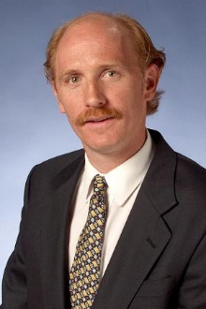Chris Coulston obtained his Ph.D. in Computer Science and Engineering from the Pennsylvania State University in 1999. He obtained his M.S. and B.S in Computer Engineering from the Pennsylvania State University in 1994 and 1992 respectively. Chris has industry experience working for IBM in Manassas, VA and Accu-Weather in State College, PA. He joined the faculty at Penn State Erie, The Behrend College in 1999. He has experience teaching design-oriented courses in digital systems, embedded systems, computer architecture, and database management systems. Chris’ research interests are in Steiner tree routing algorithms and artificial life. He is currently an Associate Professor of Electrical and Computer at Penn State Behrend and also serves as Chairperson of the program.